EXP.NO: 2 **Write JavaScript Programme to validate the following fields of the HTML**

**Registration Page.**

**AIM:**

To write JavaScript code to validate user input in a registration form. The validation will

ensure that the data entered by the user meets specific criteria for each field. This will help in maintaining data integrity and prevent invalid submissions.

**ALGORITHM:**

**1. Input:**

• The user fills in the following fields: First Name, Password, E-mail, Mobile

Number, Last Name, and Address.

**2. Validation Steps:**

1. Validate First Name:

o Check if the first name contains only alphabets.

o Ensure the length of the First Name is at least 6 characters.

o If any of these conditions fail, display an error message indicating the required

input.

2. Validate Password:

o Check if the password is at least 6 characters long.

o If it is less than 6 characters, display an error message.

**3. Validate E-mail:**

o Use a regular expression to check if the email follows the standard pattern:

name@domain.com.

o Ensure that the email contains no invalid characters and matches the required

pattern.

o If it doesn&#39;t match, display an error message indicating an invalid email

format.

**4. Validate Mobile Number:**

o Check if the mobile number contains exactly 10 digits.

o Ensure there are no alphabets or special characters.

o If the number is invalid, display an error message indicating the correct

format.

**5. Validate Last Name:**

o Ensure the Last Name field is not empty.

o If it is empty, display an error message.

6. Validate Address:

o Ensure the Address field is not empty.

o If it is empty, display an error message.

**CODE:**

Index.html:

<!DOCTYPE html>

<html>

<head>

<title>Event Booking</title>

<link rel="stylesheet" href="style.css">

</head>

<body>

<nav>

<a href="index.html">Home</a>

<a href="location.html">Location</a>

<a href="booking.html">Booking</a>

<a href="about.html">About Us</a>

</nav>

<section class="hero">

<h1>Book Events Instantly 🎉</h1>

<p>Check locations, verify seating, and reserve tickets in seconds!</p>

</section>

<div class="container">

<div class="cards">

<div class="card">

<h2>📍 Live Locations</h2>

<p>View event venues with embedded maps.</p>

</div>

<div class="card">

<h2>💺 Smart Seating</h2>

<p>Check seat availability before booking.</p>

</div>

<div class="card">

<h2>⚡ Fast Registration</h2>

<p>Register and confirm tickets instantly.</p>

</div>

</div>

</div>

</body>

</html>

location.html:

<!DOCTYPE html>

<html>

<head>

<title>Locations</title>

<link rel="stylesheet" href="style.css">

</head>

<body>

<nav>

<a href="index.html">Home</a>

<a href="location.html">Location</a>

<a href="booking.html">Booking</a>

<a href="about.html">About Us</a>

</nav>

<section class="page-heading">

    <h1>📍 Event Locations</h1>

    <p>Find our event venues across Chennai</p>

</section>

<div class="map-container">

<iframe src="https://maps.google.com/maps?q=chennai&t=&z=13&ie=UTF8&iwloc=&output=embed"></iframe>

<iframe src="https://maps.google.com/maps?q=marina%20beach&t=&z=13&ie=UTF8&iwloc=&output=embed"></iframe>

<iframe src="https://maps.google.com/maps?q=velachery&t=&z=13&ie=UTF8&iwloc=&output=embed"></iframe>

</div>

</body>

</html>

Booking.html:

<!DOCTYPE html>

<html>

<head>

<title>Booking</title>

<link rel="stylesheet" href="style.css">

</head>

<body>

<nav>

<a href="index.html">Home</a>

<a href="location.html">Location</a>

<a href="booking.html">Booking</a>

<a href="about.html">About Us</a>

</nav>

<div class="booking-box">

<div class="box">

<h2>Seating</h2>

<details>

<summary><button>Check Availability</button></summary>

<div class="seats">

<label class="seat-label">

    <input type="checkbox">

    <img src="seat.jpeg" class="seat-icon">

</label>

<label class="seat-label">

    <input type="checkbox">

    <img src="seat.jpeg" class="seat-icon">

</label>

<label class="seat-label">

    <input type="checkbox">

    <img src="seat.jpeg" class="seat-icon">

</label>

<label class="seat-label">

    <input type="checkbox">

    <img src="seat.jpeg" class="seat-icon">

</label>

<label class="seat-label">

    <input type="checkbox">

    <img src="seat.jpeg" class="seat-icon">

</label>

<label class="seat-label">

    <input type="checkbox">

    <img src="seat.jpeg" class="seat-icon">

</label>

<label class="seat-label">

    <input type="checkbox">

    <img src="seat.jpeg" class="seat-icon">

</label>

<label class="seat-label">

    <input type="checkbox">

    <img src="seat.jpeg" class="seat-icon">

</label>

<label class="seat-label">

    <input type="checkbox">

    <img src="seat.jpeg" class="seat-icon">

</label>

<label class="seat-label">

    <input type="checkbox">

    <img src="seat.jpeg" class="seat-icon">

</label>

<label class="seat-label">

    <input type="checkbox">

    <img src="seat.jpeg" class="seat-icon">

</label>

<label class="seat-label">

    <input type="checkbox">

    <img src="seat.jpeg" class="seat-icon">

</label>

<label class="seat-label">

    <input type="checkbox">

    <img src="seat.jpeg" class="seat-icon">

</label>

<label class="seat-label">

    <input type="checkbox">

    <img src="seat.jpeg" class="seat-icon">

</label>

</div>

</details>

</div>

<div class="box">

<h2>Book Now</h2>

<p>After selecting seats proceed to register.</p>

<a href="register.html">

<button>Register</button>

</a>

</div>

</div>

</body>

</html>

Register.html:

<!DOCTYPE html>

<html>

<head>

<title>Register</title>

<link rel="stylesheet" href="style.css">

</head>

<body>

<nav>

<a href="index.html">Home</a>

<a href="location.html">Location</a>

<a href="booking.html">Booking</a>

<a href="about.html">About Us</a>

</nav>

<div class="booking-box">

<div class="box">

<h2>Event Registration</h2>

<form>

<input type="text" placeholder="Your Name">

<input type="email" placeholder="Email">

<input type="tel" placeholder="Phone Number">

<button>Submit</button>

</form>

</div>

</div>

</body>

</html>

About.html:

<!DOCTYPE html>

<html>

<head>

<title>About Us</title>

<link rel="stylesheet" href="style.css">

</head>

<body>

<nav>

<a href="index.html">Home</a>

<a href="location.html">Location</a>

<a href="booking.html">Booking</a>

<a href="about.html">About Us</a>

</nav>

<div class="about">

<h1>About Our Event</h1>

<p>

We provide a seamless event booking experience with real-time seating,

interactive maps, and instant registration.

</p>

<h3>📞 Contact</h3>

<p>+91 98765 43210</p>

<h3>📧 Email</h3>

<p>support@eventbook.com</p>

</div>

</body>

</html>

Style.css:

*{

    margin:0;

    padding:0;

    box-sizing:border-box;

}

html,body{

    height:100%;

    font-family: 'Segoe UI', sans-serif;

}

/* 🔥 Cinematic Background */

body{

    min-height:100vh;

    background:

    linear-gradient(rgba(0,0,0,0.6), rgba(0,0,0,0.6)),

    url("img1.jpg");

    background-size:cover;

    background-position:center;

    background-attachment:fixed;

}

/* NAVBAR */

nav{

    background:#0b1c39;

    padding:18px;

    text-align:center;

}

nav a{

    color:white;

    text-decoration:none;

    margin:0 25px;

    font-size:18px;

    font-weight:600;

    transition:.3s;

}

nav a:hover{

    color:#00ffd5;

}

/* HERO */

.hero{

    height:85vh;

    display:flex;

    justify-content:center;

    align-items:center;

    text-align:center;

    color:white;

    flex-direction:column;

}

.hero h1{

    font-size:55px;

}

.hero p{

    font-size:22px;

    margin-top:10px;

}

/* CARDS */

.container{

    width:90%;

    margin:auto;

}

.cards{

    display:flex;

    justify-content:center;

    gap:40px;

    flex-wrap:wrap;

    margin-top:60px;

}

.card{

    width:280px;

    padding:30px;

    border-radius:18px;

    text-align:center;

    background:rgba(255,255,255,0.12);

    backdrop-filter:blur(10px);

    color:white;

    transition:.4s;

}

.card:hover{

    transform:translateY(-10px);

}

button{

    padding:12px 25px;

    border:none;

    border-radius:8px;

    background:#00ffd5;

    font-weight:bold;

    cursor:pointer;

    margin-top:15px;

}

/* MAP */

.map-container{

    display:flex;

    gap:30px;

    flex-wrap:wrap;

    justify-content:center;

    margin-top:50px;

}

iframe{

    width:350px;

    height:260px;

    border-radius:12px;

    border:none;

}

/* BOOKING */

.booking-box{

    display:flex;

    flex-direction:column;

    align-items:center;

    margin-top:80px;

    gap:40px;

}

.box{

    width:320px;

    padding:30px;

    border-radius:15px;

    text-align:center;

    background:rgba(255,255,255,0.15);

    backdrop-filter:blur(12px);

    color:white;

}

/* SEATS */

details{

    margin-top:20px;

}

.seats{

    margin-top:20px;

}

.seat{

    width:35px;

    height:35px;

    background:#00ff88;

    display:inline-block;

    margin:6px;

    border-radius:6px;

}

/* REGISTER */

form{

    display:flex;

    flex-direction:column;

    gap:15px;

}

input{

    padding:10px;

    border-radius:6px;

    border:none;

}

/* ABOUT */

.about{

    width:70%;

    margin:auto;

    margin-top:80px;

    color:white;

    text-align:center;

    line-height:1.8;

}

.seat-label input{

    display:none;

}

.seat-icon{

    width:45px;

    margin:6px;

    cursor:pointer;

    transition:0.3s;

}

.seat-label input:checked + .seat-icon{

    filter: brightness(0) saturate(100%)

            invert(64%) sepia(77%)

            saturate(420%) hue-rotate(90deg);

    transform:scale(1.2);

}

**OUTPUT:**

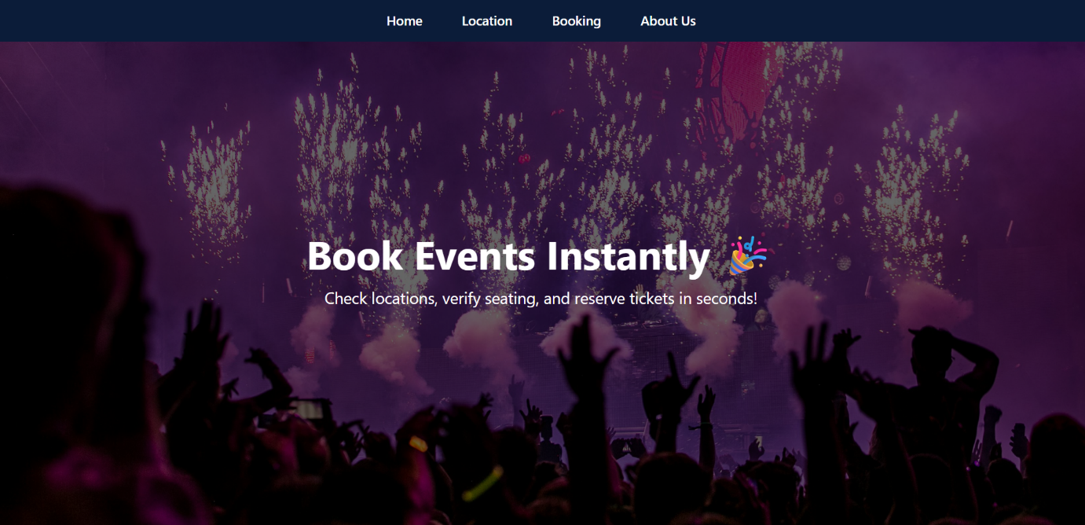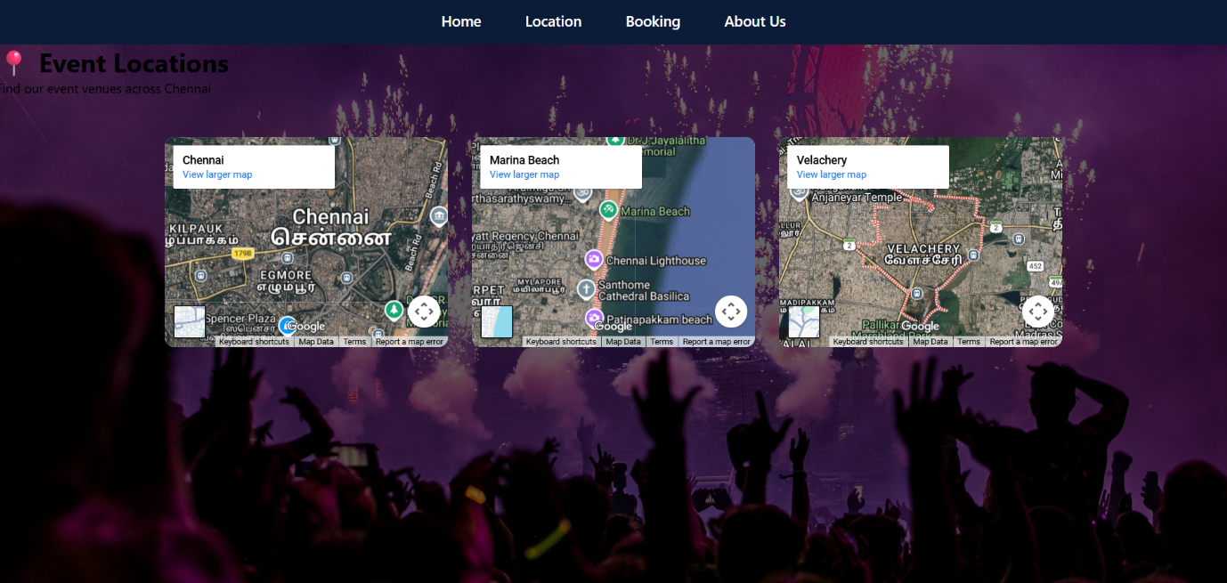

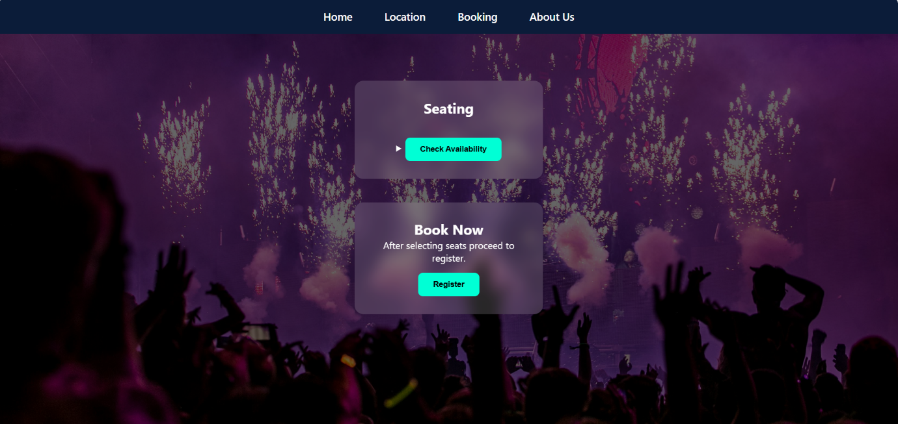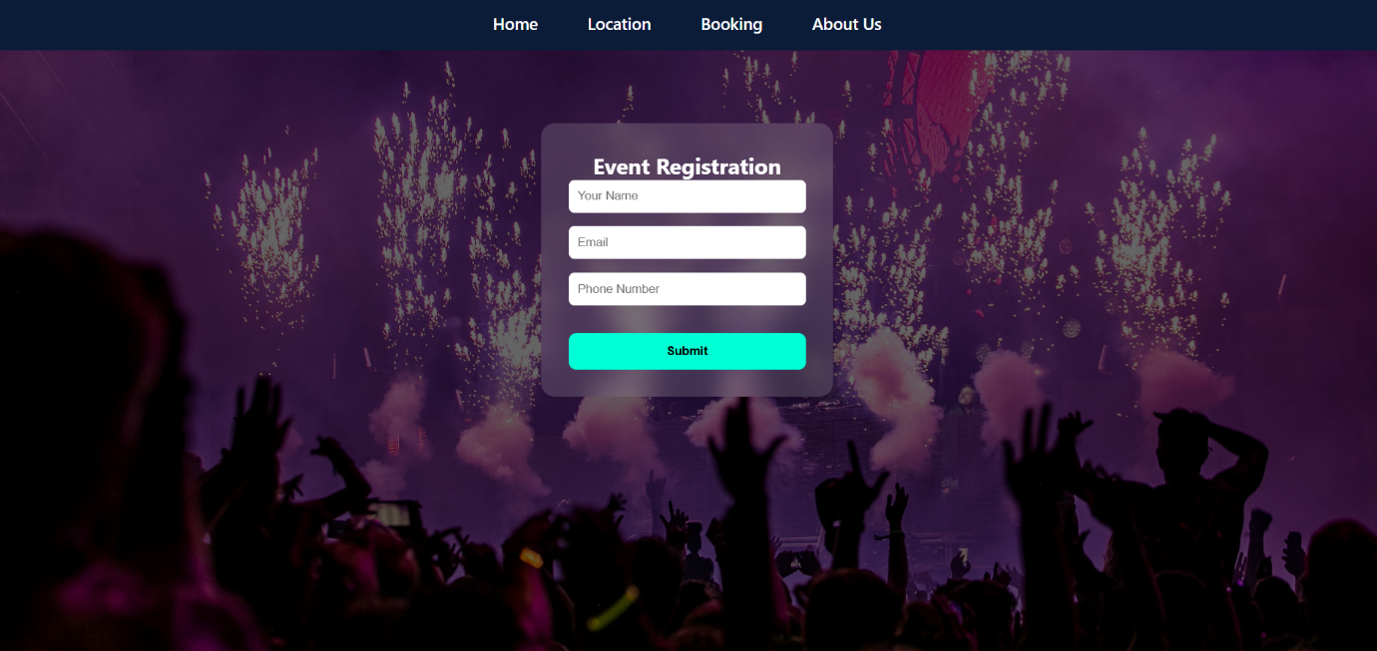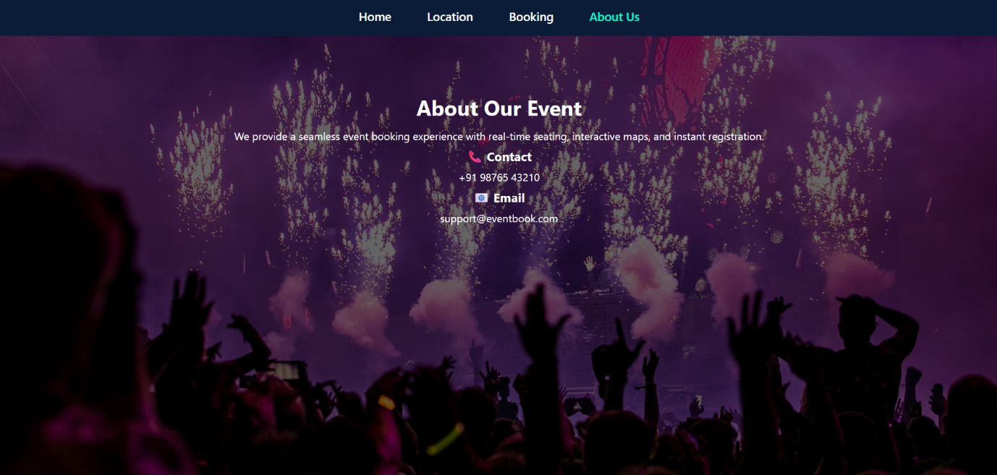

**RESULT:**

HTML page with Form is created and is validated using Javascript.